Preparation of Articles for Blockchain-Based Decentralised Voting System (2026)

Abstract—The integrity and transparency of electoral systems are critical to the functioning of a democratic society. Traditional voting methods—whether paper-based or electronic—often face challenges such as vote tampering, identity fraud, lack of transparency, delayed counting, and dependence on centralized authorities. These issues can reduce public trust in election outcomes. To address these challenges, this project proposes a Decentralized Voting System using Blockchain Technology that ensures secure, transparent, and tamper-resistant elections through a hybrid on-chain and off-chain architecture. The proposed system leverages blockchain’s immutability and transparency to securely record and count votes, while off-chain components handle real-world identity verification, biometric authentication, and legal compliance. Voters register using Aadhaar-based identity verification, where eligibility is determined based on age and constituency. Each verified voter is linked to a unique cryptographic wallet to enforce the principle of one-person-one-vote. Candidates are verified by the election authority through document validation and legal checks before being approved for participation. Once verified, candidate data and ballots are securely deployed on the blockchain through smart contracts. During the election, votes are cast through a decentralized application and recorded on the blockchain, making them immutable and publicly auditable without revealing voter identity. The system preserves voter anonymity while enabling public transparency in vote counting and result verification. After the election concludes, results are automatically calculated by smart contracts and made publicly viewable, ensuring trust and eliminating manual manipulation. By combining blockchain technology with regulated off-chain verification, the system balances technological security with legal and administrative oversight. The expected outcomes include increased election transparency, reduced fraud, faster result processing, and improved voter confidence. This project demonstrates how a hybrid blockchain-based approach can modernize electoral processes while maintaining fairness, privacy, and accountability

I. INTRODUCTION
The integrity and transparency of electoral systems are critical to the functioning of a democratic society. Traditional voting methods, whether paper-based or electronic, often face challenges such as vote tampering, identity fraud, lack of transparency, delayed counting, and dependence on centralized authorities. These issues can reduce public trust in election outcomes.
To address these challenges, this project proposes a Decentralized Voting System using Blockchain Technology that ensures secure, transparent, and tamper-resistant elections through a hybrid on-chain and off-chain architecture.
The system leverages blockchain's immutability and transparency to securely record and count votes, while off-chain components handle real-world identity verification, biometric authentication, and legal compliance. Voters register using Aadhaar-based identity verification, where eligibility is determined based on age and constituency. Each verified voter is linked to a unique cryptographic wallet to enforce the principle of one-person-one-vote.

II. RELATED STUDY
With the growth of digital governance, many countries have explored electronic voting systems to improve election efficiency. Traditional EVMs and online voting platforms aim to simplify voting but often remain centralized, making them vulnerable to tampering, cyber-attacks, and data manipulation.
Major issues in current voting systems include centralized control, lack of audit transparency, identity fraud, vote duplication, and delayed result processing. Many systems fail due to poor requirement analysis and limited stakeholder involvement. Security and privacy concerns further reduce public trust.
This project proposes a blockchain-based solution using structured requirement engineering. Blockchain ensures immutability and transparency, while off-chain verification ensures legal and identity compliance. This hybrid approach aims to overcome the weaknesses of existing systems.

III. METHODOLOGY

A. Stakeholder Identification
Stakeholders include voters, candidates, the election authority, system developers, and auditors.

B. Requirement Elicitation
Requirements were gathered through study of current election systems, surveys and discussions, and analysis of blockchain voting models. Both functional and non-functional requirements were collected.

C. Requirement Analysis
This phase involved removing conflicts and ambiguities, checking feasibility, and prioritizing security and privacy concerns.

D. Requirement Specification
Requirements were documented in an SRS using UML diagrams including Use Case, Class, Activity, and ER diagrams.

E. Requirement Validation
Requirements were reviewed with stakeholders to ensure clarity and completeness.

F. Requirement Change Management
A controlled update process was established with version control maintained throughout the project.

G. System Design Evaluation
The system was evaluated to ensure security, scalability, and reliability, with the architecture aligned to requirements.

IV. SYSTEM ARCHITECTURE
The system follows a hybrid architecture composed of three main layers. The User Interface Layer comprises voter login, candidate dashboard, and authority dashboard. The Application Layer handles Aadhaar verification, biometric authentication, wallet binding, and smart contract interaction. The Blockchain Layer manages vote storage, smart contract vote counting, and maintains an immutable audit trail. This architecture ensures secure, scalable, and transparent election management.

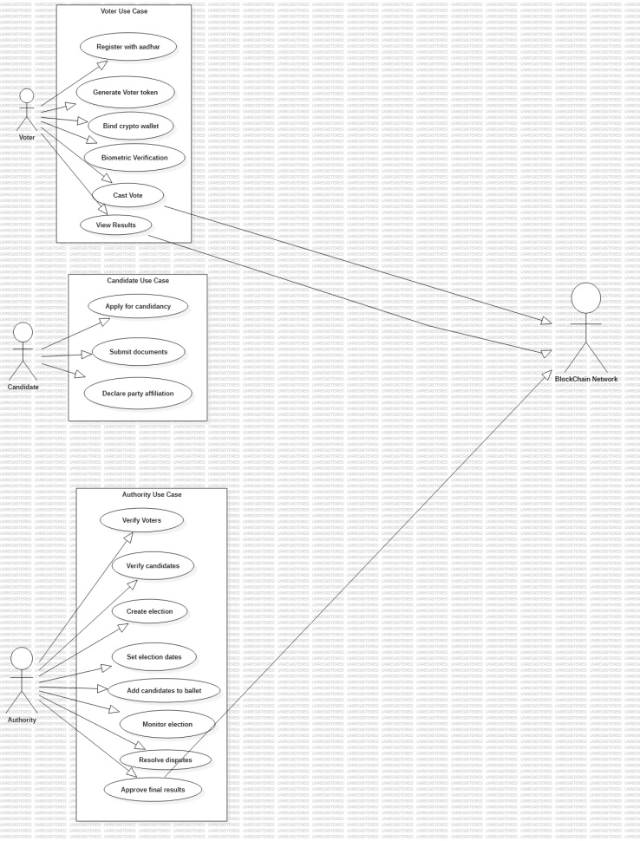
Fig.1Use Case Diagram

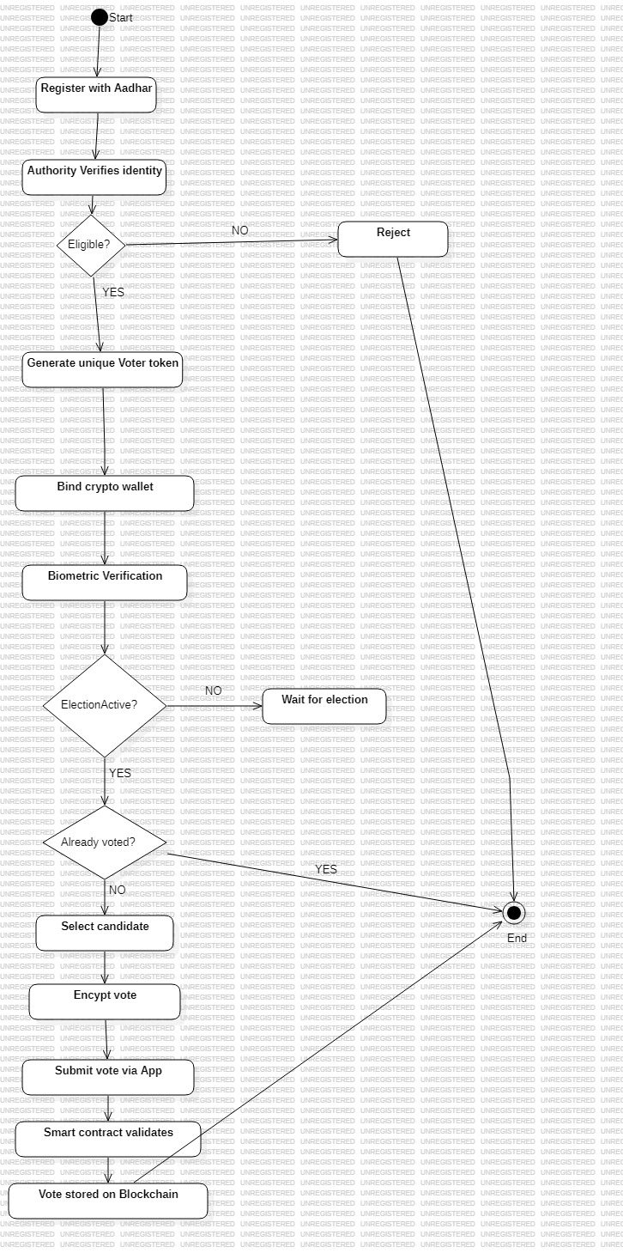
Fig.2 Activity Diagram

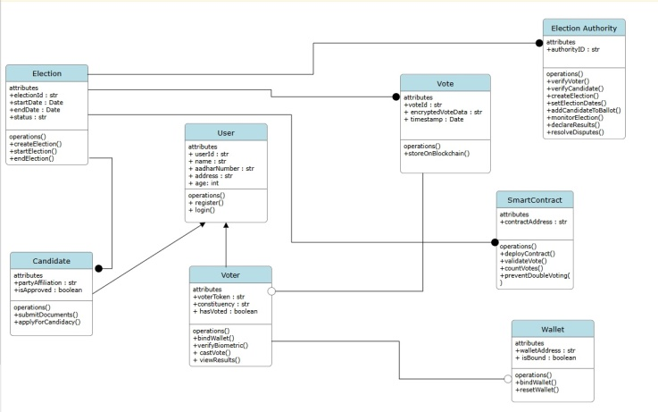
Fig.3 Class Diagram

V. IMPLEMENTATION
The system is implemented using web-based technologies. The frontend is built with HTML, CSS, and JavaScript. The backend uses Node.js or Python. The on-chain blockchain component uses Ethereum or Hyperledger, while the off-chain database uses MySQL or MongoDB.

A. Functional Requirements
The system implements Aadhaar-based registration, role-based login for voters, candidates, and authority, one Aadhaar to one wallet binding, biometric verification, area-based voting, smart contract voting, automatic counting, and public result verification.

B. Non-Functional Requirements
Security requirements include end-to-end encryption, blockchain immutability, and multi-factor authentication. Privacy is maintained through anonymous voting with no identity-vote linkage. Reliability targets 99.9% uptime with backup nodes. Performance supports millions of concurrent voters with fast vote recording. Usability features a simple UI with multi-language support. Scalability supports national election scale with high concurrency.

VI. RESULTS AND DISCUSSION
Expected outcomes of the proposed system include tamper-proof voting, faster counting, increased transparency, reduced fraud, and improved voter trust.

A. Identified Research Gap
Many existing voting systems lack transparency and strong identity verification. Poor requirement engineering leads to insecure systems.

B. Need for Improvement
The system addresses identified gaps through strong security measures, a hybrid on-chain/off-chain model, structured requirement analysis, and legal compliance.

VII. CONCLUSION AND FUTURE WORK
The Blockchain-Based Voting System reduces reliance on centralized control and improves election transparency. By combining blockchain with off-chain identity verification, the system ensures secure and fair elections.
Future enhancements may include mobile voting apps, AI-based fraud detection, national ID integration, and multi-country scalability.

Glossary
Aadhaar – A 12-digit unique identity number issued by the Government of India used for identity verification.
Activity Diagram – A UML diagram that represents workflow and system processes.
Biometric Authentication – Identity verification using biological traits such as fingerprints or iris scans.
Blockchain – A decentralized and immutable digital ledger that records transactions securely across multiple nodes.
Class Diagram – A UML diagram showing system classes, attributes, and relationships.
Consensus Mechanism – A protocol used in blockchain networks to validate transactions and agree on a single version of truth.
Cryptographic Wallet – A digital wallet used to store public and private keys for blockchain transactions.
Decentralization – A system structure where control is distributed rather than managed by a single central authority.
Distributed Ledger – A database replicated across multiple nodes in a network.
End-to-End Encryption – A communication system where only communicating users can read the messages.
ER Diagram (Entity Relationship Diagram) – A diagram used to represent database structure and relationships.
Hybrid Architecture – A system combining both on-chain (blockchain) and off-chain components.
Immutability – The property of blockchain that prevents data from being altered once recorded.
Multi-Factor Authentication (MFA) – A security system requiring more than one verification method.
Node – A device participating in a blockchain network.
Off-Chain – Processes that occur outside the blockchain.
On-Chain – Processes executed directly on the blockchain network.
Smart Contract – A self-executing program stored on a blockchain that automatically enforces rules and executes transactions.
UML (Unified Modeling Language) – A standardized modeling language used to visualize system design.
Use Case Diagram – A UML diagram showing interactions between users and the system.
Wallet Binding – Linking a verified user identity to a unique blockchain wallet to enforce one-person-one-vote.

Appendix
Appendix A – System Use Case Description
Appendix B – Functional Requirement Summary Table
Appendix C – Non-Functional Requirement Summary
Appendix D – System Technology Stack

Appendix A – System Use Case Description
Actors:
Voter
Candidate
Election Authority
Auditor
Major Use Cases:
Voter Registration
Aadhaar Verification
Wallet Generation
Candidate Approval
Vote Casting
Smart Contract Vote Counting
Result Publication

Appendix B – Functional Requirement Summary
1. Aadhaar-based voter registration
2. One Aadhaar linked to one wallet
3. Candidate verification by authority
4.Secure smart contract vote casting
5. Automatic vote counting
6. Public result transparency

Appendix C – Non-Functional Requirement Summary
1. Encryption, blockchain immutability, MFA
2. Anonymous voting, no vote-identity linkage
3. Supports high concurrency
4. 99.9% uptime with backup nodes
5. National-level deployment readiness

Appendix D – System Technology Stack
Frontend: HTML, CSS, JavaScript
Backend: Node.js / Python
Blockchain: Ethereum / Hyperledger
Database (Off-chain): MySQL / MongoDB

References and Footnotes

References
https://journals.ieeeauthorcenter.ieee.org/create-your-ieee-journal-article/create-the-text-of-your-article/ieee-editorial-style-manual/.
https://learnmeabitcoin.com/

